


Scope and Storyboard for Costs MI

AMR Manchester

By SVR

Table of Contents

1 Document Revision History 2
1.1. Document Location 2
1.2. Revision History 2
1.3. Approvals 2
1.4. Distribution 2
2 Summary of Scope 3
3 Screen design 4
4 Workflow 8
5 Navigation 9
6 SQL Tables 10
7 Stored Procedures 18
8 Tasks & Reminders 19
9 Document Templates 20

Document Revision History

Document Location
Full File Path
X:\Applications\Flosuite\Scopes\Costs\Costs MI\2011-11-10 FLO44 Scope and Storyboard for Costs MI V0.1.doc

Revision History
Version Number | Revision Date | Summary of Changes | Changes marked | Author
0.1 | 10/11/2011 | First issue | N/A | SVR

Approvals
Name | Signature | Title | Date of Issue | Version

Distribution
Name | Title | Date of Issue | Version

Summary of Scope

The purpose of this scope is to outline the provisions that the FloCase system will need to make to allow users to handle the recording of appropriate Management information on cases and Matters assigned to Costs

It is envisioned that whilst the process itself may be of a complex nature the system should provide a simplified generic solution that merely tracks dates and has a certain amount of supervision inbuilt to assist the Team Leaders in ensuring key tasks involved in these process are dealt with in a timely manner.

  - Costs MI

This Scope and Storyboard document refers only to the MI requirements identified by the Costs Team. Costs MI should be viewed as separate from any client or case level MI collected in the system and will require new tabs in the Case Banner.

As Costs may act on behalf of either the Paying Party, or the Receiving Party, or even both (where the paying party in a case is also a receiving party, for example after a successful Part 20 Claim), the Costs MI screens have been designed to allow the collation of both Paying Party costs and Receiving Party costs in the same matter.

The source fields for the Costs MI requirements were taken from spreadsheets supplied by the Costs Team, and discussed with the Aderant MI team. The two spreadsheets provided included case level information which is captured or displayed within FloCase, but not necessarily on the Costs MI screens as designed.

The MI structure for Costs MI is drawn from the existing MI structure in the FloCase system. The MI tabs are populated via a fetch from the client MI Field set, depending upon the MI Work Type. The Costs MI Set is defined by its work type of Costs, and has a distinct set of field labels and values within the Client MI Field Set, as well as stand alone tables to which data entered is to be saved in the database.

Fetch and Save functions are already in existence for the MI tabs and the source data from Aderant is populated by views from the Flocase system on the Aderant data. Costs MI requires no data to be written back to Aderant fields.

Screen design

  - Costs Dates Tab

A New Tab is required for Costs MI to be visible once the Assign Case to Costs Task set out in FLO41 Costs Negotiations is successfully completed and the case has been assigned to costs. The tab should have two pages:
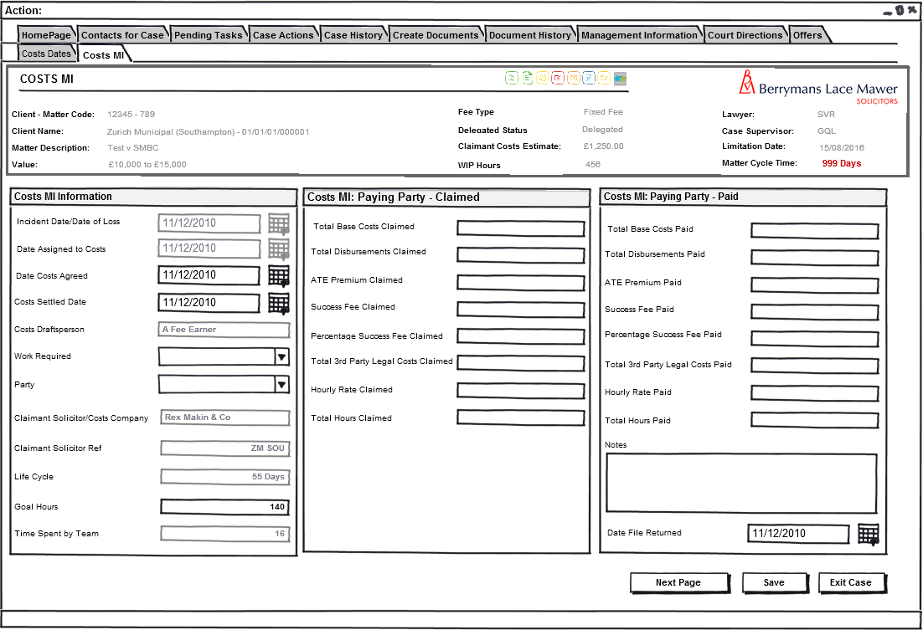
Fig 1: Costs MI Screen 1

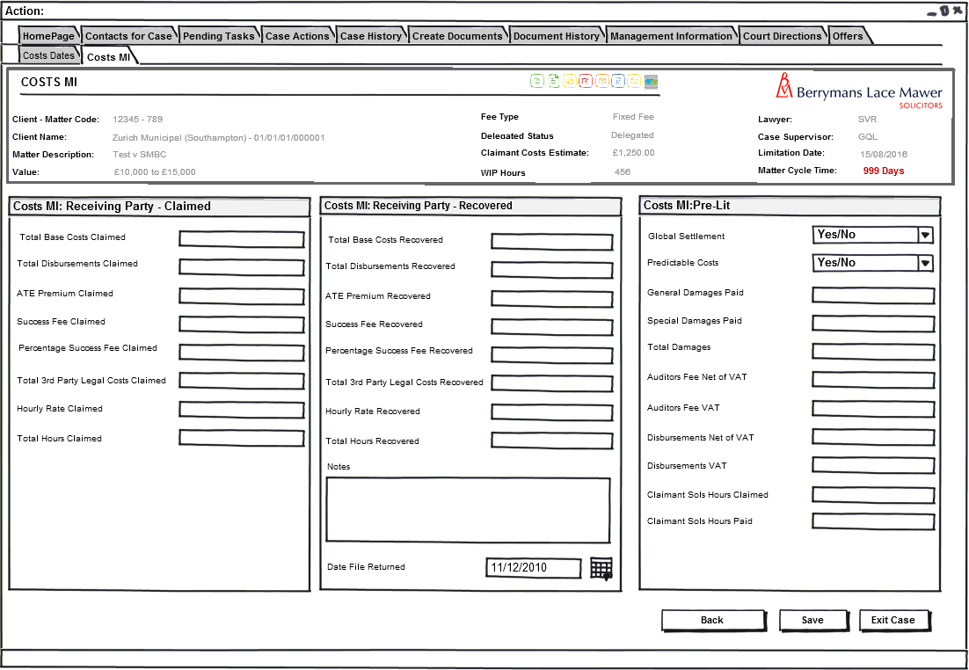
Fig 2: Costs MI Screen 2

    - Form Behaviour on Load

The Costs MI Tab should only be visible if there is a Bit value in the field dbo.Case_CostsAssgn = 1. see Fig 3: Costs Case Information from Negotiations Flow:
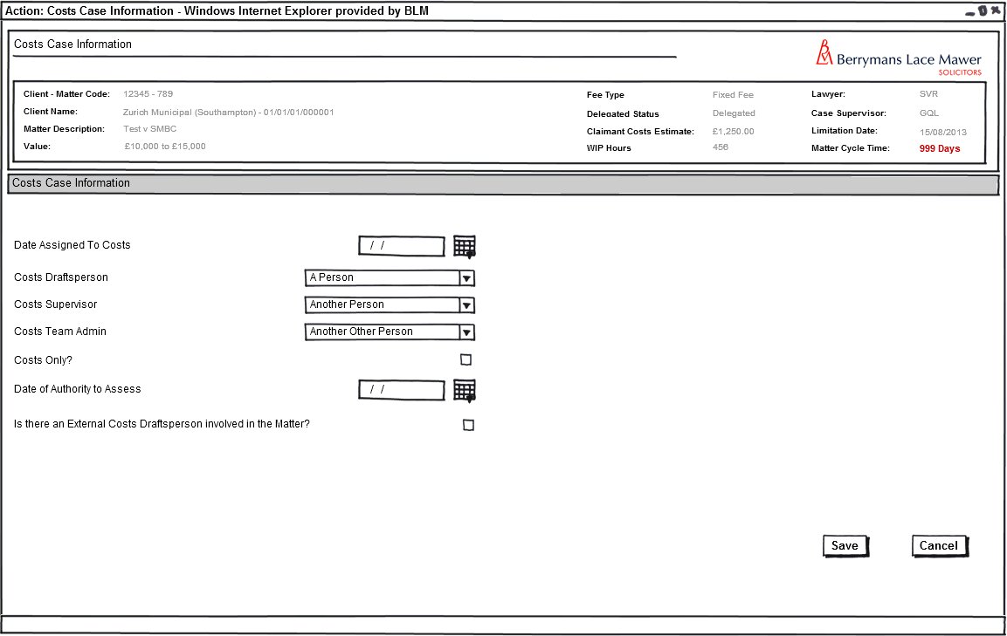
Fig 3: Costs Case Information Form (Negotiations FLO41)

    - Form Items Page 1:

The Costs MI field set is defined in the table below. MI sets are determined from the table ClientMIFieldSet. The new Costs items will have a ClientMIFieldSet_ClientMIDefCode of ‘Costs’

The Table and field to which Costs MI values are to be stored is recorded in the MIFieldDefinition Table in the DataField column. The table below sets out which table and field the values entered or calculated on the Costs MI form are to be saved to.

Label  ClientMIFieldSet_MIFieldLabel | MI Field Set Code  ClientMIFieldSet_MIFieldDefCode | Save Values Back to  MIFieldDefinition_DataField | Input Field Description
Incident Date/Date of Loss | ClientMIFieldSet_CostsAccDt | Read Only | Read Only
Date Assigned to Costs | ClientMIFieldSet_CostAssDte' | CaseKeyDates_Date where @pKeyDateCode = 'CostAssDte' | Read Only
Date Costs Agreed | ClientMIFieldSet_DteCostsAgrd | CaseKeyDates_Date | Date Picker
Costs Settled Date | ClientMIFieldSet_DteCostsSttld | CaseKeyDates_Date | Date Picker
Costs Draftsperson | ClientMIFieldSet_CostsFE | AppUser_UserName | Read Only
Work Required | ClientMIFieldSet_CostsWorkType | Costs_CostsWorkType | Combo box
Party | ClientMIFieldSet_CostsParty | Costs_Party | Combo box
Claimant Solicitor/Costs Company | CaseContacts_ContactID | Read Only | Read Only
Claimant Solicitor Ref | CaseContacts_Reference | Read Only | Read Only
Life Cycle | ClientMIFieldSet_CostsLifeCycle | Calculated from Date Assigned to Costs CaseKeyDates_Date where @pKeyDateType = 'CostAssDte' to today or to new CaseKeyDate_Date where @pKeyDateType = 'DteCostsAgrd' is present | Read Only - Days
Goal Hours | ClientMIFieldSet_CostsGoalHrs | Costs_CostsGoalHrs | Number
Time Spent by Team | ClientMIFieldSet_CostsTimeSpent | Costs_CostsTimeSpent | Number
Total Base Cost Claimed | ClientMIFieldSet_PCSCostsClaimed | Costs_PCSCostsClaimed | Text - Money
Total Disbursements Claimed | ClientMIFieldSet_PCSDisbClaimed | Costs_PCSDisbClaimed | Text - Money
ATE Premium Claimed | ClientMIFieldSet_PTPATEClmd | Costs_PTPATEClmd | Text - Money
Success Fee Claimed | ClientMIFieldSet_PSuccessFeeClmd | Costs_PSuccessFeeClmd | Text - Money
Percentage Success Fee Claimed | ClientMIFieldSet_PSucessPercentClmd | Costs_PSuccessPercentClmd | Text - Percentage
Total Third Party Legal Costs Claimed | ClientMIFieldSet_PTotalCSCostsClaimed | Costs_PTotalCSCostsClaimed | Text - Money
Hourly Rate Claimed | ClientMIFieldSet_PHourlyRateClaimed | Costs_PHourlyRateClaimed | Text - Money
Total Hours Claimed | ClientMIFieldSet_PCSHoursClaimed | Costs_PCSHoursClaimed | Number
Total 3rd Party Legal Costs paid | ClientMIFieldSet_PCSCostsPaid | Costs_PCSCostsPaid | Text - Money
Total Disbursements paid | ClientMIFieldSet_PCSDisbPaid | Costs_PCSDisbPaid | Text - Money
ATE Premium paid | ClientMIFieldSet_PATEPremiumPaid | Costs_PATEPremiumPaid | Text - Money
Success Fee Paid | ClientMIFieldSet_PSuccessFeePaid | Costs_PSuccessFeePaid | Text - Money
Percentage S/F paid | ClientMIFieldSet_PSuccessPercentPaid | Costs_PSuccessPercentPaid | Text - Percentage
Total 3rd Party legal costs paid | ClientMIFieldSet_PTotalCSCostsPaid | Costs_PTotalCSCostsPaid | Text - Money
Hourly Rate Paid | ClientMIFieldSet_PCSHourlyRatePaid | Costs_PCSHourlyRatePaid | Text - Money
Total Hours Paid | ClientMIFieldSet_PCSHoursPaid | Costs_PCSHoursPaid | Number
Notes | ClientMIFieldSet_CostsMINotes | Costs_PCostsMINotes | Text
Date File Returned | ClientMIFieldSet_CostsFileRtn | CaseKeyDates_Date @pKeyDatesType = CostsFileRtn | Date Picker
Total Base Cost Claimed | ClientMIFieldSet_RCSCostsClaimed | Costs_RCSCostsClaimed | Text - Money
Total Disbursements Paid | ClientMIFieldSet_RCSDisbClaimed | Costs_RCSDisbClaimed | Text - Money
ATE Premium | ClientMIFieldSet_RTPATEClmd | Costs_RTPATEClmd | Text - Money
Success Fee Claimed | ClientMIFieldSet_RSuccessFeeClmd | Costs_RSuccessFeeClmd | Text - Money
Percentage S/F Claimed | ClientMIFieldSet_RSucessPercentClmd | Costs_RSuccessPercentClmd | Text - Percentage
Total 3rd Party Legal Costs | ClientMIFieldSet_RTotalCSCostsClaimed | Costs_RTotalCSCostsClaimed | Text - Money
Hourly Rate Claimed | ClientMIFieldSet_RHourlyRateClaimed | Costs_RHourlyRateClaimed | Text - Money
Total Hours Claimed | ClientMIFieldSet_RCSHoursClaimed | Costs_RCSHoursClaimed | Number
Total Base Costs Recovered | ClientMIFieldSet_RCSCostsRCVD | Costs_RCSCostsRCVD | Text - Money
Total Disbursements Recovered | ClientMIFieldSet_RCSDisbRCVD | Costs_RCSDisbRCVD | Text - Money
ATE Premium Recovered | ClientMIFieldSet_RATEPremiumRCVD | Costs_RATEPremiumRCVD | Text - Money
Success Fee Recovered | ClientMIFieldSet_RSuccessFeeRCVD | Costs_RSuccessFeeRCVD | Text - Money
Percentage S/F Recovered | ClientMIFieldSet_RSuccessPercentRCVD | Costs_RSuccessPercentRCVD | Text - Percentage
Total 3rd Party legal costs Recovered | ClientMIFieldSet_RTotalCSCostsRCVD | Costs_RTotalCSCostsRCVD | Text - Money
Hourly Rate Recovered | ClientMIFieldSet_RCSHourlyRateRCVD | Costs_RCSHourlyRateRCVD | Text - Money
Total Hours Recovered | ClientMIFieldSet_RCSHoursRCVD | Costs_RCSHoursRCVD | Number
Notes | ClientMIFieldSet_CostsMINotes | Costs_RCostsMINotes | Text
Date File Returned | ClientMIFieldSet_CostsFileRtn | CaseKeyDates_Date @pKeyDatesType = CostsFileRtn | Date Picker
Global Settlement? | ClientMIFieldSet_CostsGlobSett | Costs_GlobSett | Combo box
Predictable Costs? | ClientMIFieldSet_CostsPredCosts | Costs_PredCosts | Combo box
Special Damages paid | ClientMIFieldSet_SpDmStVI | Financial_SpecialDamagesPaid | Text - Money
Total Damages | ClientMIFieldSet_GenDamSett | Financial_DamagesPaid | Text - Money
Auditors Fee Net of VAT | ClientMIFieldSet_AuditNetVAT | Costs_AuditNetVAT | Text - Money
VAT Applied to Cost Auditors Fee | ClientMIFieldSet_AuditVAT | Costs_AuditVAT | Text - Money
Disbursements Net of VAT | ClientMIFieldSet_DisbNetVAT | Costs_DisbNetVAT | Text - Money
VAT applied to Disbursements | ClientMIFieldSet_DisbVAT | Costs_DisbVAT | Text - Money
Total Cost Auditors fee (inc VAT) | ClientMIFieldSet_AudiitIncVAT | Costs_AudiitIncVAT | Text - Money

    - Form Behaviour on Save

Values to be saved to relevant fields using the existing MI stored procedure ClientMIFieldSet_Save.

Workflow

Costs MI does not currently have any workflow associated. The Tab may be loaded upon completion of a reminder task or other workflow task. The Tab should not be visible unless the Case has been assigned to costs.

Navigation

  - Where will the Flow be launched from

- There is no specific flow for Costs MI. The Tab may be loaded from a reminder task but also should be available for direct Navigation once the case has been assigned to costs.

  - Where will the Flow be launched from

- Navigation away from the tab will be by the normal methods.

SQL Tables

  - Tables

    - New Data Table in Database: None

Add field list with types (I know this is in the fields section but it avoids confusion)

No new tables required for Costs MI. See additions to existing tables below for details:

  - New fields

New MI and Financial data fields to be added to the dbo.Costs table:

Field | Settings
Costs_CostsWorkType | NVARCHAR 10, Null
Costs_Party | NVARCHAR 10, Null
Costs_CostsGoalHrs | INT, NULL
Costs_CostsTimeSpent | INT, NULL
Costs_PCSCostsClaimed | MONEY, NULL
Costs_PCSDisbClaimed | MONEY, NULL
Costs_PTPATEClmd | MONEY, NULL
Costs_PSuccessFeeClmd | MONEY, NULL
Costs_PSuccessPercentClmd | INT, NULL
Costs_PTotalCSCostsClaimed | MONEY, NULL
Costs_PHourlyRateClaimed | MONEY, NULL
Costs_PCSHoursClaimed | INT, NULL
Costs_PCSCostsPaid | MONEY, NULL
Costs_PCSDisbPaid | MONEY, NULL
Costs_PATEPremiumPaid | MONEY, NULL
Costs_PSuccessFeePaid | MONEY, NULL
Costs_PSuccessPercentPaid | INT, NULL
Costs_PTotalCSCostsPaid | MONEY, NULL
Costs_PCSHourlyRatePaid | MONEY, NULL
Costs_PCSHoursPaid | INT, NULL
Costs_PCostsMINotes | NVARCHAR 255, NULL
Costs_RCSCostsClaimed | MONEY, NULL
Costs_RCSDisbClaimed | MONEY, NULL
Costs_RTPATEClmd | MONEY, NULL
Costs_RSuccessFeeClmd | MONEY, NULL
Costs_RSuccessPercentClmd | INT, NULL
Costs_RTotalCSCostsClaimed | MONEY, NULL
Costs_RHourlyRateClaimed | MONEY, NULL
Costs_RCSHoursClaimed | INT, NULL
Costs_RCSCostsRCVD | MONEY, NULL
Costs_RCSDisbRCVD | MONEY, NULL
Costs_RATEPremiumRCVD | MONEY, NULL
Costs_RSuccessFeeRCVD | MONEY, NULL
Costs_RSuccessPercentRCVD | INT, NULL
Costs_RTotalCSCostsRCVD | MONEY, NULL
Costs_RCSHourlyRateRCVD | MONEY, NULL
Costs_RCSHoursRCVD | INT, NULL
Costs_RCostsMINotes | NVARCHAR 255, NULL
Costs_GlobSett | Bit, NULL
Costs_PredCosts | Bit, NULL
Costs_AuditNetVAT | MONEY, NULL
Costs_AuditVAT | MONEY, NULL
Costs_DisbNetVAT | MONEY, NULL
Costs_DisbVAT | MONEY, NULL
Costs_AudiitIncVAT | MONEY, NULL

  - Existing Field Set Accessed by this Scope:

ClientMIFieldSet_MIFieldDefCode | MIFieldDefinition_DataField | Field Settings
ClientMIFieldSet_CostsAccDt | Read Only | Read Only
ClientMIFieldSet_CostAssDte' | CaseKeyDates_Date where @pKeyDateCode = 'CostAssDte' | Read Only
ClientMIFieldSet_DteCostsAgrd | CaseKeyDates_Date | SMALLDATETIME, NULL
ClientMIFieldSet_DteCostsSttld | CaseKeyDates_Date | SMALLDATETIME, NULL
ClientMIFieldSet_CostsFE | AppUser_UserName | Read Only
CaseContacts_ContactID | Read Only | Read Only
CaseContacts_Reference | Read Only | Read Only
ClientMIFieldSet_CostsLifeCycle | Calculated from Date Assigned to Costs CaseKeyDates_Date where @pKeyDateType = 'CostAssDte' to today or to new CaseKeyDate_Date where @pKeyDateType = 'DteCostsAgrd' is present | Read Only
ClientMIFieldSet_CostsFileRtn | CaseKeyDates_Date @pKeyDatesType = CostsFileRtn | SMALLDATETIME, NULL
ClientMIFieldSet_CostsFileRtn | CaseKeyDates_Date @pKeyDatesType = CostsFileRtn | SMALLDATETIME, NULL
ClientMIFieldSet_SpDmStVI | Financial_SpecialDamagesPaid | MONEY, NULL
ClientMIFieldSet_GenDamSett | Financial_DamagesPaid | MONEY, NULL
Case_ClientUno | Read Only | Read Only
Case_MatterUno | Read Only | Read Only
Case_MatterDescription | Read Only | Read Only
Case_ClientCode | Read Only | Read Only
AppUser_UserName | Read Only | Read Only
Case_BranchCode | Read Only | Read Only
MatterContact_MatterContactID | Read Only | Read Only
Case_MatterType | Read Only | Read Only
Case_CourtTrack | Read Only | Read Only
Case_BLMREF | Read Only | Read Only
Case_PriCaseType | Read Only | Read Only
NEW CONTACT REQUIREMENT TO BE DEVELOPED IN 5.12 | Read Only | Read Only
CaseContacts_ContactID | Read Only | Read Only
CaseContacts_ContactID | Read Only | Read Only
CaseContacts_ContactID | Read Only | Read Only
PartEight_AppType = 'Costs' | Read Only | Read Only
PartEight_CostsResult | Read Only | Read Only

  - Lookups

New Lookup Values in ClientMIFieldSet as Follows:

ClientMIFieldSet_ID | ClientMIFieldSet_ClientMIDEFCODE | ClientMIFieldSet_MIFieldDefCode | ClientMIFieldSet_MIFieldPosition | ClientMIFieldSet_MIFieldLabel
842 | Costs | CostsAccDt | 1 | Incident Date/Date of Loss
843 | Costs | CostAssDte' | 2 | Date Assigned to Costs
844 | Costs | DteCostsAgrd | 3 | Date Costs Agreed
845 | Costs | DteCostsSttld | 4 | Costs Settled Date
846 | Costs | CostsFE | 5 | Costs Draftsperson
847 | Costs | CostsWorkType | 6 | Work Required
848 | Costs | CostsParty | 7 | Party
849 | Costs | CaseContacts_ContactID | 8 | Claimant Solicitor/Costs Company
850 | Costs | CaseContacts_Reference | 9 | Claimant Solicitor Ref
851 | Costs | CostsLifeCycle | 10 | Life Cycle
852 | Costs | CostsGoalHrs | 11 | Goal Hours
853 | Costs | CostsTimeSpent | 12 | Time Spent by Team
854 | Costs | PCSCostsClaimed | 13 | Total Base Cost Claimed
855 | Costs | PCSDisbClaimed | 14 | Total Disbursements Claimed
856 | Costs | PTPATEClmd | 15 | ATE Premium Claimed
857 | Costs | PSuccessFeeClmd | 16 | Success Fee Claimed
858 | Costs | PSucessPercentClmd | 17 | Percentage Success Fee Claimed
859 | Costs | PTotalCSCostsClaimed | 18 | Total 3rd Party Legal Costs Claimed
860 | Costs | PHourlyRateClaimed | 19 | Hourly Rate Claimed
861 | Costs | PCSHoursClaimed | 20 | Total Hours Claimed
866 | Costs | PCSCostsPaid | 25 | Total 3rd Party Legal Costs paid
867 | Costs | PCSDisbPaid | 26 | Total Disbursements paid
868 | Costs | PATEPremiumPaid | 27 | ATE Premium paid
869 | Costs | PSuccessFeePaid | 28 | Success Fee Paid
870 | Costs | PSuccessPercentPaid | 29 | Percentage S/F paid
871 | Costs | PTotalCSCostsPaid | 30 | Total 3rd Party Legal Costs paid
872 | Costs | PCSHourlyRatePaid | 31 | Hourly Rate Paid
873 | Costs | PCSHoursPaid | 32 | Total Hours Paid
874 | Costs | CostsMINotes | 33 | Notes
877 | Costs | CostsFileRtn | 36 | Date File Returned
878 | Costs | RCSCostsClaimed | 37 | Total Base Cost Claimed
879 | Costs | RCSDisbClaimed | 38 | Total Disbursements Paid
880 | Costs | RTPATEClmd | 39 | ATE Premium
881 | Costs | RSuccessFeeClmd | 40 | Success Fee Claimed
882 | Costs | RSucessPercentClmd | 41 | Percentage S/F Claimed
883 | Costs | RTotalCSCostsClaimed | 42 | Total 3rd Party Legal Costs
884 | Costs | RHourlyRateClaimed | 43 | Hourly Rate Claimed
885 | Costs | RCSHoursClaimed | 44 | Total Hours Claimed
890 | Costs | RCSCostsRCVD | 49 | Total Base Costs Recovered
891 | Costs | RCSDisbRCVD | 50 | Total Disbursements Recovered
892 | Costs | RATEPremiumRCVD | 51 | ATE Premium Recovered
893 | Costs | RSuccessFeeRCVD | 52 | Success Fee Recovered
894 | Costs | RSuccessPercentRCVD | 53 | Percentage S/F Recovered
895 | Costs | RTotalCSCostsRCVD | 54 | Total 3rd Party legal costs Recovered
896 | Costs | RCSHourlyRateRCVD | 55 | Hourly Rate Recovered
897 | Costs | RCSHoursRCVD | 56 | Total Hours Recovered
898 | Costs | CostsMINotes | 57 | Notes
901 | Costs | CostsFileRtn | 60 | Date File Returned
902 | Costs | CostsGlobSett | 61 | Global Settlement?
903 | Costs | CostsPredCosts | 62 | Predictable Costs?
904 | Costs | SpDmStVI | 63 | Special Damages paid
905 | Costs | GenDamSett | 64 | Total Damages
906 | Costs | AuditNetVAT | 65 | Auditors Fee Net of VAT
907 | Costs | AuditVAT | 66 | VAT Applied to Cost Auditors Fee
908 | Costs | DisbNetVAT | 67 | Disbursements Net of VAT
909 | Costs | DisbVAT | 68 | VAT applied to Disbursements
910 | Costs | AudiitIncVAT | 69 | Total Cost Auditors fee (inc VAT)

New Values in MIFieldDefinition as Follows:

MIFieldDefinition_MIFieldDefinitionID | MIFieldDefinition_MIFieldCode | MIFieldDefinition_MIFieldTypeCode | MIFieldDefinition_FieldDescription | MIFieldDefinition_MILKPFieldCode | MIFieldDefinition_DataField
TBA | CostsAccDt | MIDTEINP | Incident Date/Date of Loss | where @pKeyDateCode = ‘Accident’ | CaseKeyDates_Date
TBA | CostAssDte' | MIDTEINP | Date Assigned to Costs | where @pKeyDateCode = 'CostAssDte' | CaseKeyDates_Date
TBA | DteCostsAgrd | MIDTEINP | Date Costs Agreed | where @pKeyDateCode = ‘DteCstAgrd’ | CaseKeyDates_Date
TBA | DteCostsSttld | MIDTEINP | Costs Settled Date | where @pKeyDateCode = ‘CstSttlDte’ | CaseKeyDates_Date
TBA | CostsFE | MITEXT | Costs Draftsperson | where @pAppUserRoleCode = ‘CFE’ | AppUser_UserName
TBA | CostsWorkType | MILKP | Work Required | CstsWrktype | Costs_CostsWorkType
TBA | CostsParty | MILKP | Party | CostsParty | Costs_Party
TBA | CaseContacts_ContactID | MITEXT | Claimant Solicitor/Costs Company | TBD | CaseContacts_SearchName
TBA | CaseContacts_Reference | MITEXT | Claimant Solicitor Ref | TBD | CaseContacts_Reference
TBA | CostsLifeCycle | MIINT | Life Cycle | NULL | Calculated from Date Assigned to Costs CaseKeyDates_Date where @pKeyDateType = 'CostAssDte' to today or to new CaseKeyDate_Date where @pKeyDateType = 'DteCostsAgrd' is present
TBA | CostsGoalHrs | MIINT | Goal Hours | NULL | Costs_CostsGoalHrs
TBA | CostsTimeSpent | MIINT | Time Spent by Team | NULL | Costs_CostsTimeSpent
TBA | PCSCostsClaimed | MIMONEY | Total Base Cost Claimed | NULL | Costs_PCSCostsClaimed
TBA | PCSDisbClaimed | MIMONEY | Total Disbursements Claimed | NULL | Costs_PCSDisbClaimed
TBA | PTPATEClmd | MIMONEY | ATE Premium Claimed | NULL | Costs_PTPATEClmd
TBA | PSuccessFeeClmd | MIMONEY | Success Fee Claimed | NULL | Costs_PSuccessFeeClmd
TBA | PSucessPercentClmd | MIINT | Percentage Success Fee Claimed | NULL | Costs_PSuccessPercentClmd
TBA | PTotalCSCostsClaimed | MIMONEY | Total 3rd Party Legal Costs Claimed | NULL | Costs_PTotalCSCostsClaimed
TBA | PHourlyRateClaimed | MIMONEY | Hourly Rate Claimed | NULL | Costs_PHourlyRateClaimed
TBA | PCSHoursClaimed | MIINT | Total Hours Claimed | NULL | Costs_PCSHoursClaimed
TBA | PCSCostsPaid | MIMONEY | Total 3rd Party Legal Costs paid | NULL | Costs_PCSCostsPaid
TBA | PCSDisbPaid | MIMONEY | Total Disbursements paid | NULL | Costs_PCSDisbPaid
TBA | PATEPremiumPaid | MIMONEY | ATE Premium paid | NULL | Costs_PATEPremiumPaid
TBA | PSuccessFeePaid | MIMONEY | Success Fee Paid | NULL | Costs_PSuccessFeePaid
TBA | PSuccessPercentPaid | MIINT | Percentage S/F paid | NULL | Costs_PSuccessPercentPaid
TBA | PTotalCSCostsPaid | MIMONEY | Total 3rd Party Legal Costs paid | NULL | Costs_PTotalCSCostsPaid
TBA | PCSHourlyRatePaid | MIMONEY | Hourly Rate Paid | NULL | Costs_PCSHourlyRatePaid
TBA | PCSHoursPaid | MIINT | Total Hours Paid | NULL | Costs_PCSHoursPaid
TBA | CostsMINotes | MITEXT | Notes | NULL | Costs_PCostsMINotes
TBA | CostsFileRtn | MIDTEINP | Date File Returned | Where @pKeyDatesType = CostsFileRtn | CaseKeyDates_Date
TBA | RCSCostsClaimed | MIMONEY | Total Base Cost Claimed | NULL | Costs_RCSCostsClaimed
TBA | RCSDisbClaimed | MIMONEY | Total Disbursements Paid | NULL | Costs_RCSDisbClaimed
TBA | RTPATEClmd | MIMONEY | ATE Premium | NULL | Costs_RTPATEClmd
TBA | RSuccessFeeClmd | MIMONEY | Success Fee Claimed | NULL | Costs_RSuccessFeeClmd
TBA | RSucessPercentClmd | MIINT | Percentage S/F Claimed | NULL | Costs_RSuccessPercentClmd
TBA | RTotalCSCostsClaimed | MIMONEY | Total 3rd Party Legal Costs | NULL | Costs_RTotalCSCostsClaimed
TBA | RHourlyRateClaimed | MIMONEY | Hourly Rate Claimed | NULL | Costs_RHourlyRateClaimed
TBA | RCSHoursClaimed | MIINT | Total Hours Claimed | NULL | Costs_RCSHoursClaimed
TBA | RCSCostsRCVD | MIMONEY | Total Base Costs Recovered | NULL | Costs_RCSCostsRCVD
TBA | RCSDisbRCVD | MIMONEY | Total Disbursements Recovered | NULL | Costs_RCSDisbRCVD
TBA | RATEPremiumRCVD | MIMONEY | ATE Premium Recovered | NULL | Costs_RATEPremiumRCVD
TBA | RSuccessFeeRCVD | MIMONEY | Success Fee Recovered | NULL | Costs_RSuccessFeeRCVD
TBA | RSuccessPercentRCVD | MIINT | Percentage S/F Recovered | NULL | Costs_RSuccessPercentRCVD
TBA | RTotalCSCostsRCVD | MIMONEY | Total 3rd Party legal costs Recovered | NULL | Costs_RTotalCSCostsRCVD
TBA | RCSHourlyRateRCVD | MIMONEY | Hourly Rate Recovered | NULL | Costs_RCSHourlyRateRCVD
TBA | RCSHoursRCVD | MIINT | Total Hours Recovered | NULL | Costs_RCSHoursRCVD
TBA | CostsMINotes | MITEXT | Notes | NULL | Costs_RCostsMINotes
TBA | CostsFileRtn | MIDTEINP | Date File Returned | Where @pKeyDatesType = CostsFileRtn | CaseKeyDates_Date
TBA | CostsGlobSett | MIMONEY | Global Settlement? | NULL | Costs_GlobSett
TBA | CostsPredCosts | MIMONEY | Predictable Costs? | NULL | Costs_PredCosts
TBA | SpDmStVI | MIMONEY | Special Damages paid | NULL | Financial_SpecialDamagesPaid
TBA | GenDamSett | MIMONEY | Total Damages | NULL | Financial_DamagesPaid
TBA | AuditNetVAT | MIMONEY | Auditors Fee Net of VAT | NULL | Costs_AuditNetVAT
TBA | AuditVAT | MIMONEY | VAT Applied to Cost Auditors Fee | NULL | Costs_AuditVAT
TBA | DisbNetVAT | MIMONEY | Disbursements Net of VAT | NULL | Costs_DisbNetVAT
TBA | DisbVAT | MIMONEY | VAT applied to Disbursements | NULL | Costs_DisbVAT
TBA | AudiitIncVAT | MIMONEY | Total Cost Auditors fee (inc VAT) | NULL | Costs_AudiitIncVAT

New Values in dbo.KeyDatesType as Follows:

dbo.KeyDatesType_Description | dbo.KeyDatesType_Code
Costs Settled Date | CstSttlDte
Cost File Return | CostsFileRtn
Date Costs Agreed | DteCstAgrd

New Values in dbo.LookupCode as Follows:

dbo.LookupCode_Description | dbo.LookupCode_LookupTypeCode
Bill | CstWrkType
PoD | CstWrkType
Advice | CstWrkType
Joint Statement | CstWrkType
Negotiation | CstWrkType
Paying | CostsParty
Receiving | CostsParty
Both | CostsParty

  - Fields & Forms

Label | Input Type | Table | Field Name | Field Value Type | Mandatory? | Rule | Form | Description

Stored Procedures

  - Fetch

New Stored Procedure:

  - Save

New Stored Procedure:

Tasks & Reminders

Task | Who On | Trigger | Behaviour on Select | Scheduling | Conditions/Parameters

Document Templates

Please list below details of any document required as part of this scope.

Status:  New / Existing / Replacement  (please state) | Received Document Name (from business) | Document File Name  (ie Document.dot) | Document Description  (as viewed on FloCase) | Template Description Code  (Code for auto description) | Template Group:  BLM/ Documents/ Court Doc/ Letters/ Other  (Please State)

/tmp/lo/0000.doc

